AGENDA FOR THE MEETING OF DITTON PRIORS PARISH COUNCIL TO BE HELD ON Thursday 12TH February 2026 at 7.30pm in small hall of the village hall Ditton Priors.

- Public Session.
- Acceptance of apologies.
- Dispensations:
- Shropshire Council Report.
- Approve the minutes of the meeting being held on Thursday 22nd January 2026.
6. Roads:
a. Any recent problems.
b. Road closures.
- B4364 Neenton -Chetton 22nd February 2025
- Un named road between Derrington and Monkhopton 16th – 20 February 2026 STW.
- Ashfield Road 26th 27 February 2026 STW
- Ashfield Road 23rd March 2026 BT Pole
- Unnamed Road between A458 Muckley and Monkhopton (Acton Round) Openreach. 13th April 2026 – 8th May 2026.
- Station Road Ditton Priors. 29th March 2026 Openreach.
- South Road Ditton Priors 11th March Openreach.
- Unnamed road between B4368 and Monkhopton 4th-5th March.
c. Notification of a road car rally.
7. Highway Maintenance:
  - Restoring Shropshire’s Verges. Confirmation of presentation.
8. Defibrillators:
9. Planning:
a. New Applications:
  - Decisions:
c. Any urgent planning matters.
10. Finance:
  - Invoices to pay.:
- Mrs. J Madeley £601.02fpo
- Pension Shropshire Council £256.04 fpo
- Water plus £10.99 dd
- Horizon Focus £17.99 fpo
- Ditton Priors village hall £10.00
- Mr R Williams £55.30
- Vision ict £219.46
- RBL \Poppy Appeal £27.50
  - Bank Reconciliation. Jan
  - Consider grant to St John’s PCC.
  - VAT refund received £1543.95.
  - Consider how reserves will be developed.
  - Consider Reserves Policy.
11. Allotments.
12. Consider IT Policy.
13. Email Addresses.
14. Correspondence.
- Shropshire Hills forum and Field Visits Wed 29th April. Clun Memorial Hall
- MMCLT (Middle Marches CLT) Restoring Shropshire Verges event 13th March 2026. Church Stretton
15. Item at Chair’s discretion.
16. Date of next scheduled meeting Thursday 12th March 2026.
17. Confidential Item.
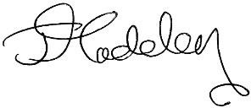
785175 Clerk@dittonpriorsparishcouncil.co.uk
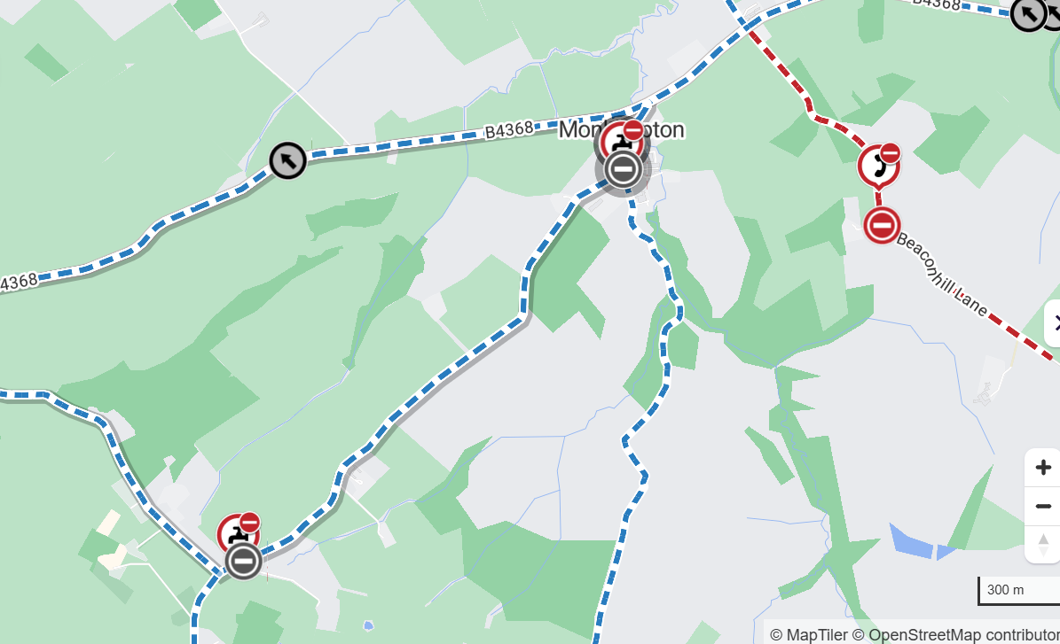

10e. After the decision to not approve the recommended budget an explanation is needed to explain to the auditors both internal and external what plans the Parish Council has to ensure an unallocated reserve of at least £13500 ie one quarter’s general expenses will be arrived at. Clerk presents a reserve policy to determine the future.

